**THE LOWER COELOMATES**

These are also referred to as **Protostomes**. All the animals here are coelomates with true coelom. They have a complete digestive tract with separate mouth and anus; and most have well developed nervous, excretory and circulatory systems. These include Annelids, Molluscs and Arthropods.

**Advantages of a Coelom**

The coelom serves as a fluid-filled space that protects internal organs by cushioning them. This also permits a separation between the muscles of the body wall and those in the wall of the digestive tract.

Coelom also permits organs to develop and move independently of the outer wall of the body.

It also provides space of the gonads to develop.

As an enclosed compartment of fluid under pressure, the coelom can serve as a hydrostatic skeleton which provides shape to the body of soft animals.

In some animals, fluid within the coelom helps to transport materials such as food, oxygen and wastes. Cells bathed by the coelomic fluid can exchange materials by receiving nutrients and oxygen from the coelomic fluid and excretes wastes into it.

**LIFE ON LAND**

Living things are gradually becoming less and less dependent on water, evolving with additional structures to cope with terrestrial challenges. Many modern invertebrates still inhabit the sea. The earthworm is a terrestrial animal, but most annelids are marine. A few snails inhabit the land, but most molluscs also live in the sea. Among the arthropods, most crustaceans (crabs, lobsters etc) are also marine forms; but insects and spiders are very successful terrestrial animals.

**Challenges of living on Land**

The chief problem facing all terrestrial organisms is that of drying out in the absence of a surrounding watery medium. A body covering adopted to minimize fluid loss helps solve this problem in many land animals. Also the location of the respiratory surface deep within the animal helps prevent fluid loss. Thus, while gills are typically located externally, lungs and tracheal tubes in insects are located internally.

Another problem associated with life on land is supporting the body against the pull of gravity in the absence of the buoyant effect of water. Earthworms for example do not have this challenge since they have small bodies. Larger animals generally need some sort of supporting skeleton.

Arthropods and most molluscs have a tough exoskeleton, a supporting armor that covers the body. Vertebrates have an endoskeleton, a supporting framework within the body.

Reproduction on land poses still another challenge. Many aquatic forms shed their gametes in the water where fertilization occurs. The surrounding water serves as an effective shock absorber, protecting the delicate embryos as they develop. Some land animals including most amphibians, return to water for reproduction; their larval forms develop in the water. Earthworms, Land snails, insects, reptiles, birds and mammals engage in internal fertilization.

Another important adaptation to reproduction on land is the tough, protective shell that surrounds the eggs of many species. This shell protects the developing embryo from drying out. Another alternative adaptation for terrestrial reproduction is the development of the embryo within the moist body of the mother.

**PHYLUM A N N E L I D A**

Annelids are worms with segmentation or **metamerism** (which is the division of the body along its length) of a series of repeated segments that look like a set of fused rings. These smaller segments are also called **metameres** and are arranged in a linear series.

These segments are marked externally by circular rings called **annuli** (the name of the phylum refers to this characteristic). Each segment is internally separated from the next by a membrane or **septa** and bears stiff **chitin** reinforced **bristles or chaeta or setae** on each side of the body.

Earthworms are among 15,000 or so species and range in length from less than 1mm to the 3m giant Australian earthworm. They live in marine freshwater habitats and damp, moist soil.

**BODY PLAN (MORPHOLOGY)**

The annelid body typically has a two part head composed of a **prostomium** and a **peristomium**, followed by a segmented body and a terminal portion called the **pygidium** bearing an anus.

The head and pygidium are not considered to be segments. New segments differentiate during development just in front of the pygidium. Thus the oldest segments are at the anterior end and the youngest segments are at the posterior end.

Each segment typically contains circulatory, respiratory, nervous and excretory structures as well as a coelom. The gut extends through all the chambers from mouth to anus. Between the gut and other body organs, there is a fluid-filled cavity called the **coelom** which acts as a **hydrostatic skeleton.** Movement is by alternate contraction of circular and longitudinal muscles in the body wall.

Traditionally, annelids are divided among 3 classes: Polychaeta, Oligochaeta and Hirudinida.

**General Characteristics of Annelids**

1. Body is metameric and has bilateral symmetry.
2. Body wall with outer circular muscle layers, inner longitudinal muscle layers. The outer transparent layer is moist cuticle secreted by epithelium.
3. Chitinous setae often present. Setae is absent in leeches.
4. Coelom is well developed and divided by septa except in leeches. Coelomic fluid acts as hydrostatic skeleton.
5. They are hermaphroditic or have separate sexes. There is asexual reproduction by budding in some.
6. They are marine, freshwater and terrestrial.
7. They have a triploblastic body.
8. Epithelium secretes a transparent, moist cuticle.

**Class Polychaeta**

This is the largest class of Annelids with more than 10,000 species most of them marine. Most polychaetes are 5 – 10 cm long, and some are less than 1mm, others may be as long as 3m. They may be brightly colored in reds and greens, iridescent, or dull. Many live under rocks in coral crevices or in abandoned shells. A number of species burrow into mud or sand and build their own tubes on submerged objects or in bottom sediment. Others adopt the tubes or homes of other animals and some are planktonic.

Polychaetes play a significant part in marine food chains because they are eaten by fish, crustaceans, and many other predators. They differ from other annelids in having a well-differentiated head with specialized sense organs; paired appendages called **parapodia** on most segments and no clitellum.

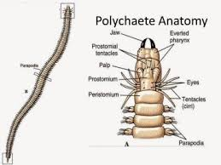As their name implies, they have many setae, usually arranged in bundles on the parapodia. Parapodia show a wide variety of adaptations among polychaetes including specialization for swimming, respiration, crawling, maintaining position in a burrow, pumping water through a burrow. Polychaetes are dioecious, have a reproductive system.

Polychaetes are often divided into 2 morphological groups based on their activity:

1. **Sedentary** polychaetes – they spend much or all of their time in tubes or permanent burrows. Many of them have elaborate devices for feeding and respiration.
2. **Errant** polychaetes – these include the free-swimming pelagic forms, active burrowers, crawlers and tubeworms that only leave their tubes for feeding or breeding. E.g. are *Nereis* spp. (clam worms), Scale worms, Fire worms, and Tubeworms.

**Class Oligochaeta**

This class has more than 3000 species which occur in great variety of sizes and habitats. They include the familiar earthworms and many species that live in freshwater. Most are terrestrial or freshwater forms but some are parasitic and a few live in marine or brackish water.

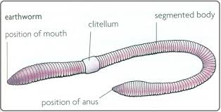They bear setae, which may be long or short, straight or curved, blunt or needlelike or arranged singly or in bundles. The setae are less numerous as the name implies compared to polychaetes. They do not have parapodia.

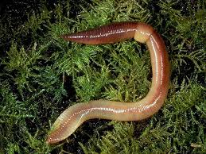General body shape of an Earthworm (*Lumbricus terrestris)*

Earthworms, sometimes called night crawlers, burrow on moist rich soil and usually live in branched, interconnected tunnels. The species commonly studied in laboratories is *Lumbricus terrestris.* It ranges in size from 12 – 30cm long.

Earthworms use peristaltic movements: contractions of circular muscles in the anterior end which lengthens the body and anchors it which then is aided by contractions of the longitudinal muscles posteriorly.

Most Oligochaetes are scavengers. Earthworms feed mainly on decaying organic matter, bits of leaves and vegetation, refuse and animal matter. They have no special respiratory organs, but gaseous exchange occurs across their moist skin.

Oligochaetes practice cross-fertilization. The **clitellum** plays an important role in reproduction including secretion of mucus to surround the worms during copulation and secretion of a cocoon to receive eggs and sperm and in which embryonation occurs. A small juvenile worm hatches from the cocoon.

**Class Hirudinida (Leeches)**

True leeches have 34 segments, entirely lack setae and possess anterior and posterior suckers. They occur predominantly in freshwater habitats. They are more abundant in tropical countries than in temperate zones. Most are between 2 and 6cm in length, but some including medicinal leeches reach 20cm.

They are usually flattened dorso-ventrally and exhibit a variety of patterns and colors: black, brown, red or olive green. Many live as carnivores or small invertebrates, some are temporary parasites, and some are permanent parasites never leaving their host.

Like oligochaetes, leeches are hermaphroditic and have a clitellum, which appears only during breeding season. The clitellum secretes a cocoon for reception of eggs.

Leeches have lost the setae used by oligochaetes in locomotion and have developed suckers for attachment while blood sucking (their gut is specialized for storage of large quantities of blood).

Most leeches crawl with looping movements of the body by attaching first one sucker and then the other pulling the body along the surface. E.g. is *Hirudo medicinalis* which feeds on human blood.

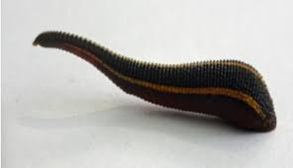

A typical Leech (*Hirudo medicinalis)*

**PHYLUM MOLLUSCA**

Mollusca (L. molluscus, soft) is one of the largest animal phyla after Arthropoda. There are over 90,000 living species and some 70,000 fossil species. Mollusca is a phylum of **soft-bodied** invertebrates characterized by an un-segmented body that is differentiated into a **Head**, a **Ventral muscular foot** used in locomotion, and a dorsal visceral hump covered by a fold of skin – the **mantle.** This mantle secretes a protective shell in many species.

Its members range in size from very small, tiny snails only a few millimeters across to the 20m long giant squid. No matter what their shape or size, all mollusks have the same basic body plan.

Their bodies are not built of segments like the segmented worms. Instead mollusks have most of their organs in one area called a **Visceral mass.** The visceral mass contains the digestive, excretory, circulatory, respiratory and reproductive organs.

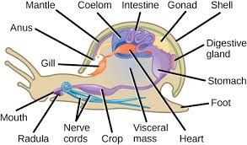Another characteristic of the mollusk body plan is a muscular foot (head foot). This may be variously adapted for locomotion, for attachment to a substratum, or for a combination of functions – like the laterally compressed “hatchet foot” of **Bivalves** or the siphon for jet propulsion in Squids and Octopuses.

A Transverse section of a Gastropod

**RADULA**

The radula is a rasping, protrusible, tongue-like organ found in all mollusks except Bivalves and most Solenogastres. It is used forfeeding and consists of a ribbon-like membrane in which is mounted rows of tiny teeth that point backwards.

Molluscs usually have a pair of nephridia connecting with the coelom and a complex nervous system (with a variety of sense organs). The primitive larva of mollusks is the **trocophore**, and in most marine mollusks the trocophore develops into a second larval stage, the **veliger.**

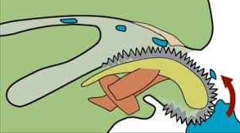

Figure: Feeding with a Radula

**CLASS GASTROPODA**

These are the most successful and largest class of mollusks containing over 70,000 species. Its members included snails, limpets, slugs, whelks, conchs, periwinkles, sea slugs, sea hares and sea butterflies.

These forms range from marine mollusks to terrestrial, air-breathing snails and slugs. Gastropods are usually sluggish, sedentary animals because most of them have heavy shells and slow locomotion. Some are specialized for climbing, swimming, or burrowing.

Most land snails do not have gills. Instead, the mantle is highly vascularized and functions as a lung. These garden snails and slugs are described as pulmonate (meaning “having a lung”).

**TORSION** - A unique feature of gastropods is torsion – a twisting of the visceral mass. As the bilateral larva develops, one side of the visceral mass grows more rapidly than the other side. This uneven growth results in rotation of the visceral mass. The visceral mass and mantle twist permanently up to 180o relative to the head. As a result, the digestive tract becomes somewhat U-shaped and the anus comes to lie above the head and gill. Example is *Helix,* the garden snail.

Diagrams of torsion

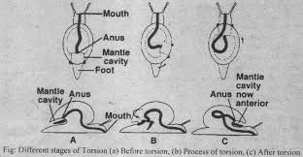

**CLASS CAUDOFOVEATA**

Members are worm-like, marine organisms ranging from 2 – 140mm in length. They are mostly burrowers and orient themselves vertically, with the terminal mantle cavity and gills at the entrance of the burrow. There are about 70 species.

They have no shell, but their body is covered with calcareous scales. They have a radula, although it is reduced in some; and their sexes are separate. They feed on microorganisms and detritus.

**CLASS SOLENOGASTRES**

There are about 250 species present. They are marine and worm-like with no shells. There are calcareous scales or spicules in their integument. Members have their head reduced and have no nephridia.

Solenogastres have no radula and no gills. Their foot is represented by a mid-ventral narrow furrow, the pedal groove. They are hermaphroditic. They are free living on the bottom, living and feeding on Cnidarians.

**CLASS POLYPLACOPHORA (many plate bearers) e.g. Chitons, Tonicella**

There are about 1000 species currently. Chitons which are the common class examples are small (2 to 5cm). The largest *(Cryptochiton* – crypto – hidden + chiton – coat of mail) rarely exceed 30cm. They prefer rocky surfaces in inter-tidal regions. Most Chitons are sedentary (stay-at-home) organisms, straying only very short distances for feeding.

CHARACTERISTICS

1. 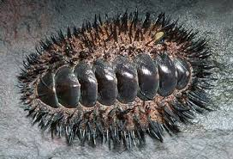Shell is composed of a longitudinal series of eight calcareous pieces.
2. Mostly bilaterally symmetrical, dorso-ventrally flattened mollusks.
3. They have ventrally flat foot which is bordered by a groove containing gills.
4. Their head is distinct, but lacks eyes and tentacles.
5. Their body is convex dorsally, and elliptical. It flattens ventrally.
6. Their radula is well developed and comprises 17 teeth.
7. A pair of nephridia is present extending from pericardium to the lateral groove.
8. The intestine is coiled and has terminal anus.
9. Sexes are separate (dioecious).

**CLASS MONOPLACOPHORA*(cap-shaped)***

About 25 species of Monoplacophorans are known. They are small and have low, rounded shell and a creeping foot. They are very small in size about 3mm to 3cm in length.

CHARACTERISTICS

1. Their shells are a single piece or valve. 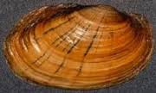
2. They have bilaterally symmetrical and segmented bodies.
3. The head is without eyes and tentacles.
4. Their foot is flat and ventral.
5. A mantle that encircles the body as a circular fold of the body wall.
6. They have externally and serially arranged gills.
7. Sexes are separate (dioecious).
8. Examples: *Neopilina galatheae*

**CLASS SCAPHOPODA *(scapha – boat; podos – foot)* e.g. Dentalium**

These are commonly referred to as tusk shells or tooth shells. They are bottom-dwelling (or benthic) mollusks. There are about 900 living species and most are 2.5 to 5cm long.

CHARACTERISTICS

1. They are exclusively marine.
2. Their body is bilaterally symmetrical which is elongated and enclosed in a tusk-like shell that opens at both ends.
3. They lack eyes, tentacles and gills.
4. Foot is reduced and used for digging.
5. Their mantle is tubular and encloses the body completely.
6. Heart is rudimentary.
7. Sexes are separate (dioecious).

**CLASS PELECYPODA (Hatchet foot)**

They are bivalved mollusks that include mussels, clams, scallops, oysters and shipworm which range in size from tiny seed shells – 1 to 2mm in length to giant South Pacific clams *Tridacnagigas* which may reach more than 1m in length.

Most bivalves are sedentary filter feeders that depend on currents produced by cilia on their gills to gather food materials.

Pearl production is a by-product of a protective device used by the animals when a foreign object (grain of sand, parasite or other) becomes lodged between the shell and mantle. The mantle secretes layers of **nacre** around the irritating object. *Meleagrina* is an oyster used extensively by the Japanese for pearl culture.

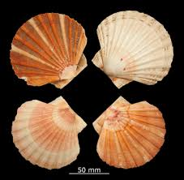 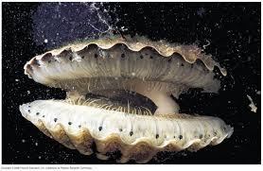

CHARACTERISTICS

1. Body is bilaterally symmetrical and laterally compressed.
2. Their shell consists of two lateral valves, that are hinged together mid-dorsally.
3. The head is not distinct, thus no radula, jaws and tentacles are absent.
4. Foot is ventral and muscular.
5. Their mantle is bi-lobed, consisting of paired right and left lobes.
6. Gills (ctenidia) are paired, one on each side.
7. Alimentary canal is coiled with large paired digestive glands.
8. Sexes are separate or united.
9. Other examples are Mytilus, Anodonta, Unio, Pecten.

**CLASS CEPHALOPODA *(Head footed animals)***

These include Squids, Octopuses, Nautiluses, Devilfish and Cuttlefish (Sepia). They range in size from 2 to 3cm. Others could go up to 30cm long e.g. *Loligo*. The giant Squid, *Architeuthis*, goes up to 60ft in length and weighs about a ton. These Squids are the largest invertebrates known.

Cephalopods are found at various depths. Octopuses are often seen in the inter-tidal zone. Lurking among rocks and crevices, but they are occasionally found at great depths. Squids which are more active are rarely found in very shallow water. Some have been taken at depths of 5000m. Nautilus is usually found near the bottom in water 50 to almost 600m deep, near islands in the Southwestern Pacific.

In these Molluscs, the foot is divided into tentacles which are located at the head away from the rest of the body. Octopuses have eight tentacles and Squids have ten. Their tentacles are covered with suction cups or suckers for grasping prey.

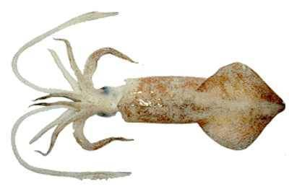

A picture of a Loligo

CHARACTERISTICS

1. Exclusively marine.
2. Body is bilaterally symmetrical with head and trunk.
3. Head bears large eyes and mouth
4. Foot altered into a series of sucker bearing arms or tentacles encircling the mouth.
5. The mouth bears jaws and radula.
6. Excretory system comprises 2 or 4 pairs of nephridia.
7. Circulatory system is closed.
8. Nervous system is highly developed and the principal ganglia are concentrated around the esophagus.
9. Sexes are separate.

**Economic Importance of Mollusca**

1. Some Mollusca are indirectly harmful to man, but most of them are beneficial. **Slugs** are injurious in gardens and cultivations by eating leaves and cutting up roots and stems of plants. The **shipworm**, *Teredo*, burrows into wooden structures immersed in the sea. It causes serious damage to wharves, piers and ships.
2. Molluscs are a great source of human food. The Oyster (a bivalve) is a delicacy in many parts of the world (Abalone, Oyster Rockefeller, Clam Chowder, Calamari – squid, Escargots).
3. Molluscs are the producers of pearls. These are used for jewelry, buttons and other types of ornaments.
4. Lime from shells of Oysters is used in feeding poultry for formation of their egg shells.
5. Some act as intermediate hosts for parasites of humans and animals.

**REVIEW QUESTIONS**

1. Into how many classes is the phylum Annelida divided? Name them with examples.
2. What three reasons constitute the economic importance of Mollusca?
3. What is a radula? And what is it used for by Molluscs?
4. What is metamerism? Which Phylum exhibits this characteristic?
5. Why are the following called that way?
   1. Cephalopods; b. Bivalves; c. Polyplacophorans
6. Why are garden snails and slugs called Pulmonate animals?
7. Describe the body plan of Annelids.